Sukkur IBA University


Data Structure Algorithm

Name: Tariq Mehmood
CMS ID: 023-23-017
Semester: 3rd
Section: E
Submitted by: Sir Riaz Hussain
Lab No: 08

Task 1
class Node {
Node left, right;
int data;

Node(int data) {
this.data = data;
left = right = null;
}
}

public class Task1 {
Node root;
public boolean isUnivalue(Node root){
if(root==null)
return true;

return dfs(root, root.data);
}
public boolean dfs(Node root, int data){
if(root==null)
return true;
if(root.data!=data)
return false;

return dfs(root.left, data) && dfs(root.right, data);
}

// Method to insert a new node
public void insert(int data) {
root = insertRect(root, data);
System.out.println("Inserted node with data: " + data);
}
Node insertRect(Node root, int data) {
if (root == null) {
return new Node(data);
}
if (data < root.data) {
root.left = insertRect(root.left, data);
}
else if (data > root.data) {
root.right = insertRect(root.right, data);
}
return root;
}

// Display root and its immediate children
public void display() {
if (root == null) {
System.out.println("The tree is empty");
return;
}
System.out.println("The Root Node: " + root.data);
if (root.left != null) {
System.out.println("Left Child of Root: " + root.left.data);
}
else {
System.out.println("Left Child of Root: null");
}
if (root.right != null) {
System.out.println("Right Child of Root: " + root.right.data);
}
else {
System.out.println("Right Child of Root: null"); // Corrected message here
}
}
public static void main(String[] args) {
Task1 tree = new Task1();
tree.insert(1);
tree.insert(1);
tree.insert(1);
tree.insert(12);
tree.insert(13);

tree.display();

System.out.println(tree.isUnivalue(tree.root));

}
}
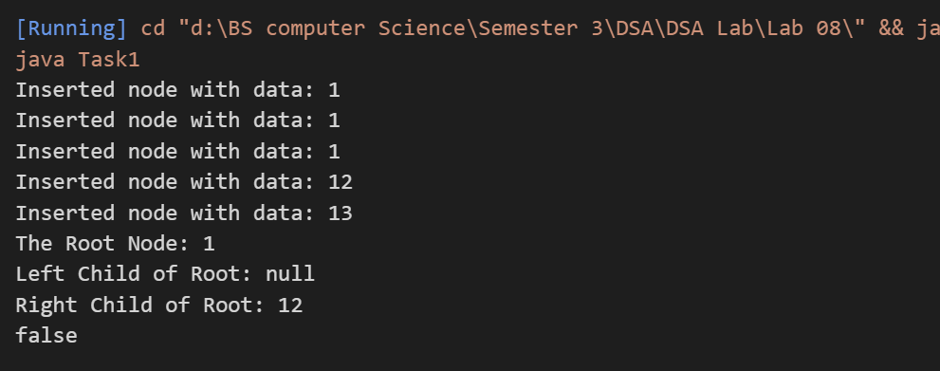

Task 2

import java.util.*;

class TreeNode{
TreeNode left;
TreeNode right;
int data;
TreeNode(int data){
this.data=data;
}

}
public class Task2{
TreeNode root;
int totalTilt=0;
// Method to calculate the total tilt
public int findTilt(TreeNode root) {
calculateTilt(root);
return totalTilt;
}
// Recursive helper method to calculate tilt of each node
int calculateTilt(TreeNode node){
if(node==null){
return 0;
}
int leftsum=calculateTilt(node.left);
int rightsum=calculateTilt(node.right);
int nodeTilt=Math.abs(leftsum-rightsum);
totalTilt=totalTilt+nodeTilt;
return node.data+leftsum+rightsum;

}
public static void main(String[] args) {
TreeNode root=new TreeNode(4);
root.left=new TreeNode(2);
root.right=new TreeNode(9);
root.left.left=new TreeNode(3);
root.left.right=new TreeNode(5);

root.right.right=new TreeNode(7);

Task2 List=new Task2();

System.out.println(" ");

int totalTilt=List.findTilt(root);
System.out.println("Total Tilt: " + totalTilt);

}
}

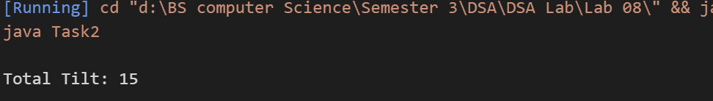
Task 4
public class Task4 {
public static class TreeNode {
int val;
TreeNode left, right;
TreeNode(int val) {
this.val = val;
}
}

public TreeNode invertTree(TreeNode root) {
if (root == null) {
return null; // Base case: If the node is null, there's nothing to invert
}

// Recursively invert the left and right subtrees
TreeNode left = invertTree(root.left);
TreeNode right = invertTree(root.right);

// Swap the left and right children
root.left = right;
root.right = left;

return root; // Return the root of the inverted tree
}

public static void main(String[] args) {

TreeNode root = new TreeNode(1);
root.left = new TreeNode(2);
root.right = new TreeNode(3);
root.left.left = new TreeNode(4);
root.left.right = new TreeNode(5);

Task4 solution = new Task4();
TreeNode invertedRoot = solution.invertTree(root);

// Print inverted tree (for testing)
System.out.println("Inverted Tree Root: " + invertedRoot.val);
System.out.println("Inverted Tree Left Child: " + invertedRoot.left.val); // Should be 3
System.out.println("Inverted Tree Right Child: " + invertedRoot.right.val); // Should be 2
}
}

